|  |  |
| --- | --- |
| AlfaisalLogoFinal | **SE 328 L: Mobile Development Lab**   * + 1. **CoE – Software Engineering**   **Alfaisal University**  **Lab 4: ListViews** |

**Course Lecturer: Dr. George Violettas Lab Instructor: Eng. Hoda Elsayed**

**Spring Semester 2021**

**Expected Time: 2 hrs Student Name: Ahmed Diab, khalid hali**

**180470,180145**

**Objectives**

*The objective of this lab is to:*

* Learning navigation basics using a listView
* Opening a website url on list item click

**Submission Style:**

* Add screenshot of the final mobile app screen you built
* Submit the project as .zip file as well that you saved using Android Studio IDE



|  |  |  |  |
| --- | --- | --- | --- |
| Ex# | *Grade* | *Out of* | *Grader Comment(s)* |
| 1 |  | *10* |  |
| **Total** |  | **10** |  |
| **Signature** |  | | |

**Create a project on Android Studio**

After clicking android Studio’s icon, follow the following steps to create a new project on Android Studio:

1. Click start a new android studio project

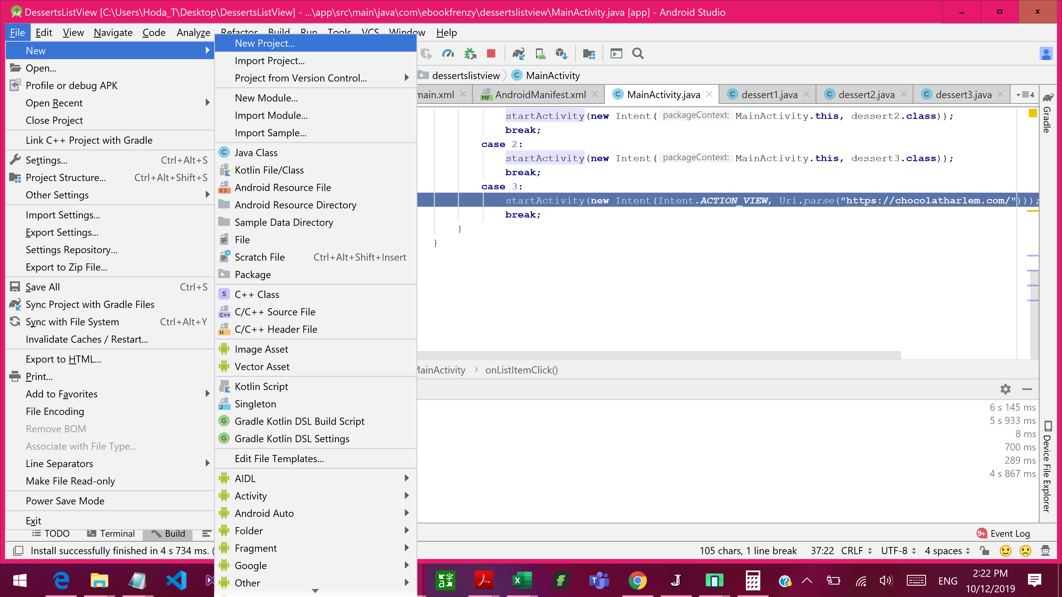

1. Click on Master/Detail Flow then click next

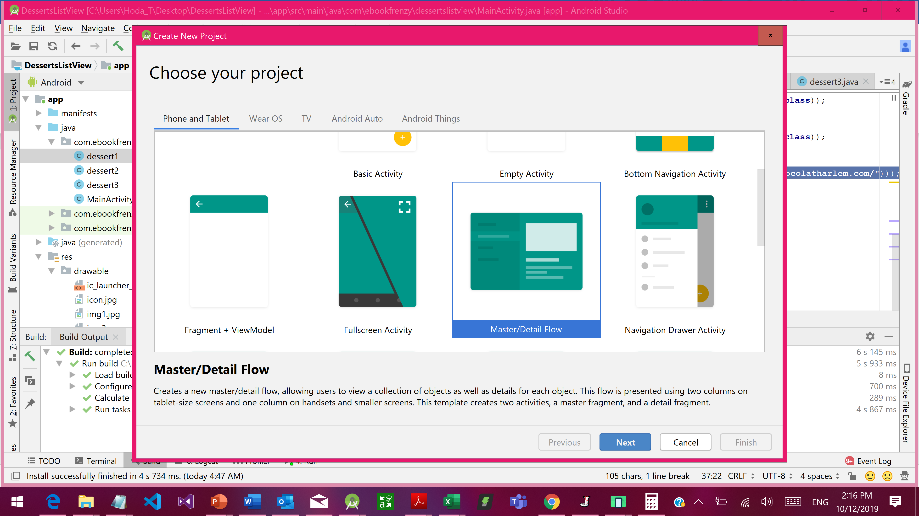

1. Give your activity a meaningful name then click finish

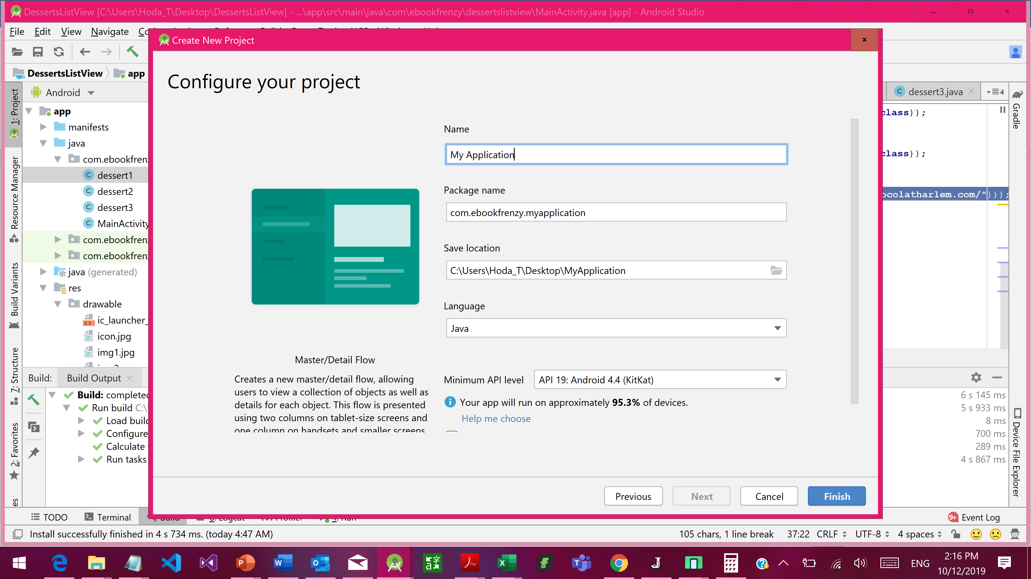

1. Place images you collect from the internet into drawable location in your project

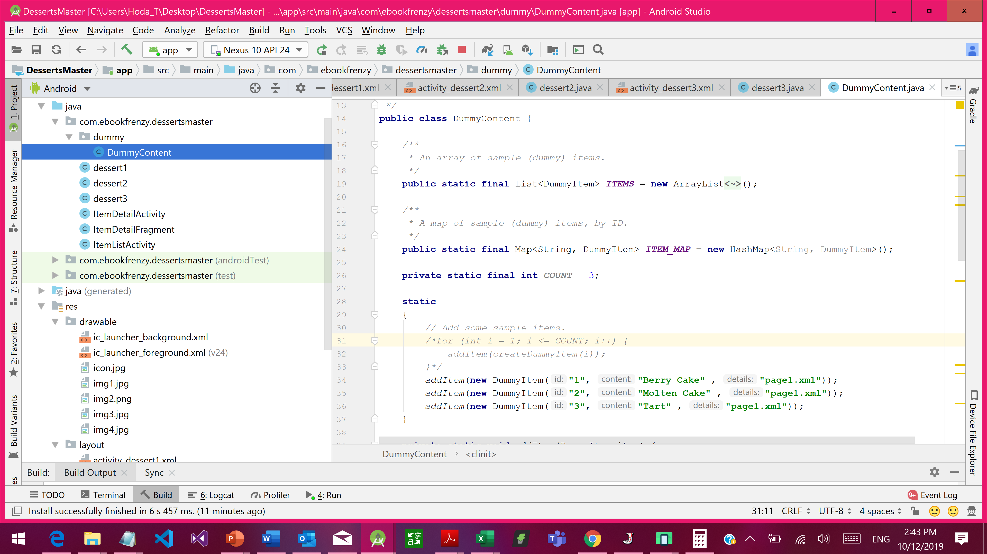

**Exercise: Desserts Catalog using ListView** Design a new application that contains a listView, in which each of the 4 items navigates the user to a new empty activity or website as shown below:

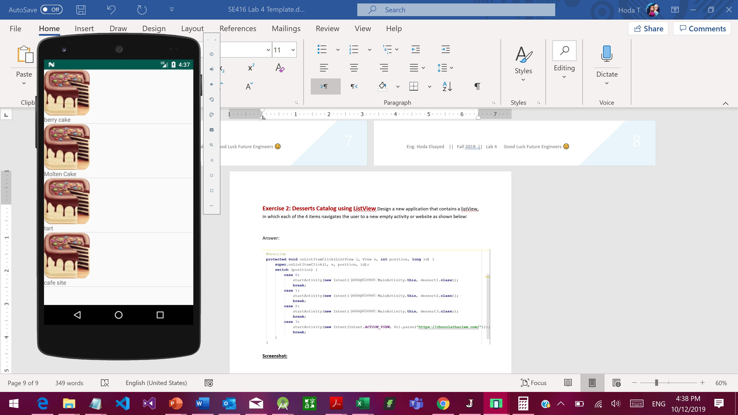

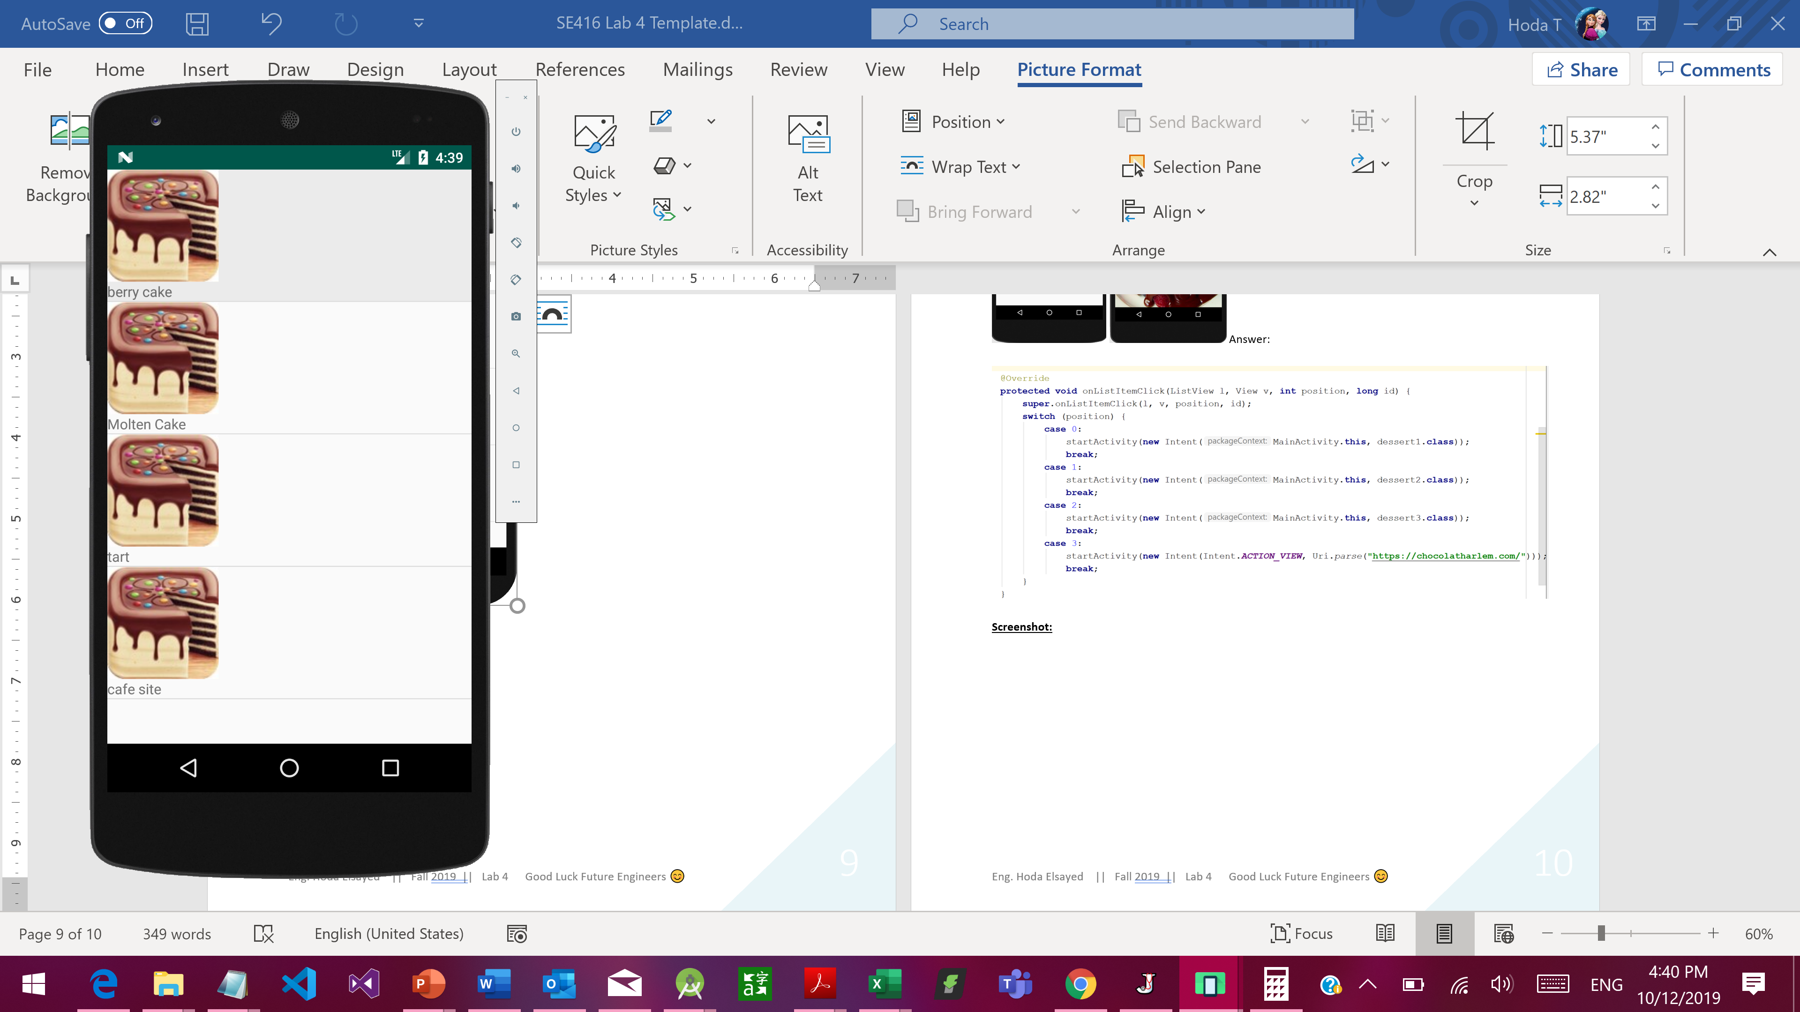 🡪 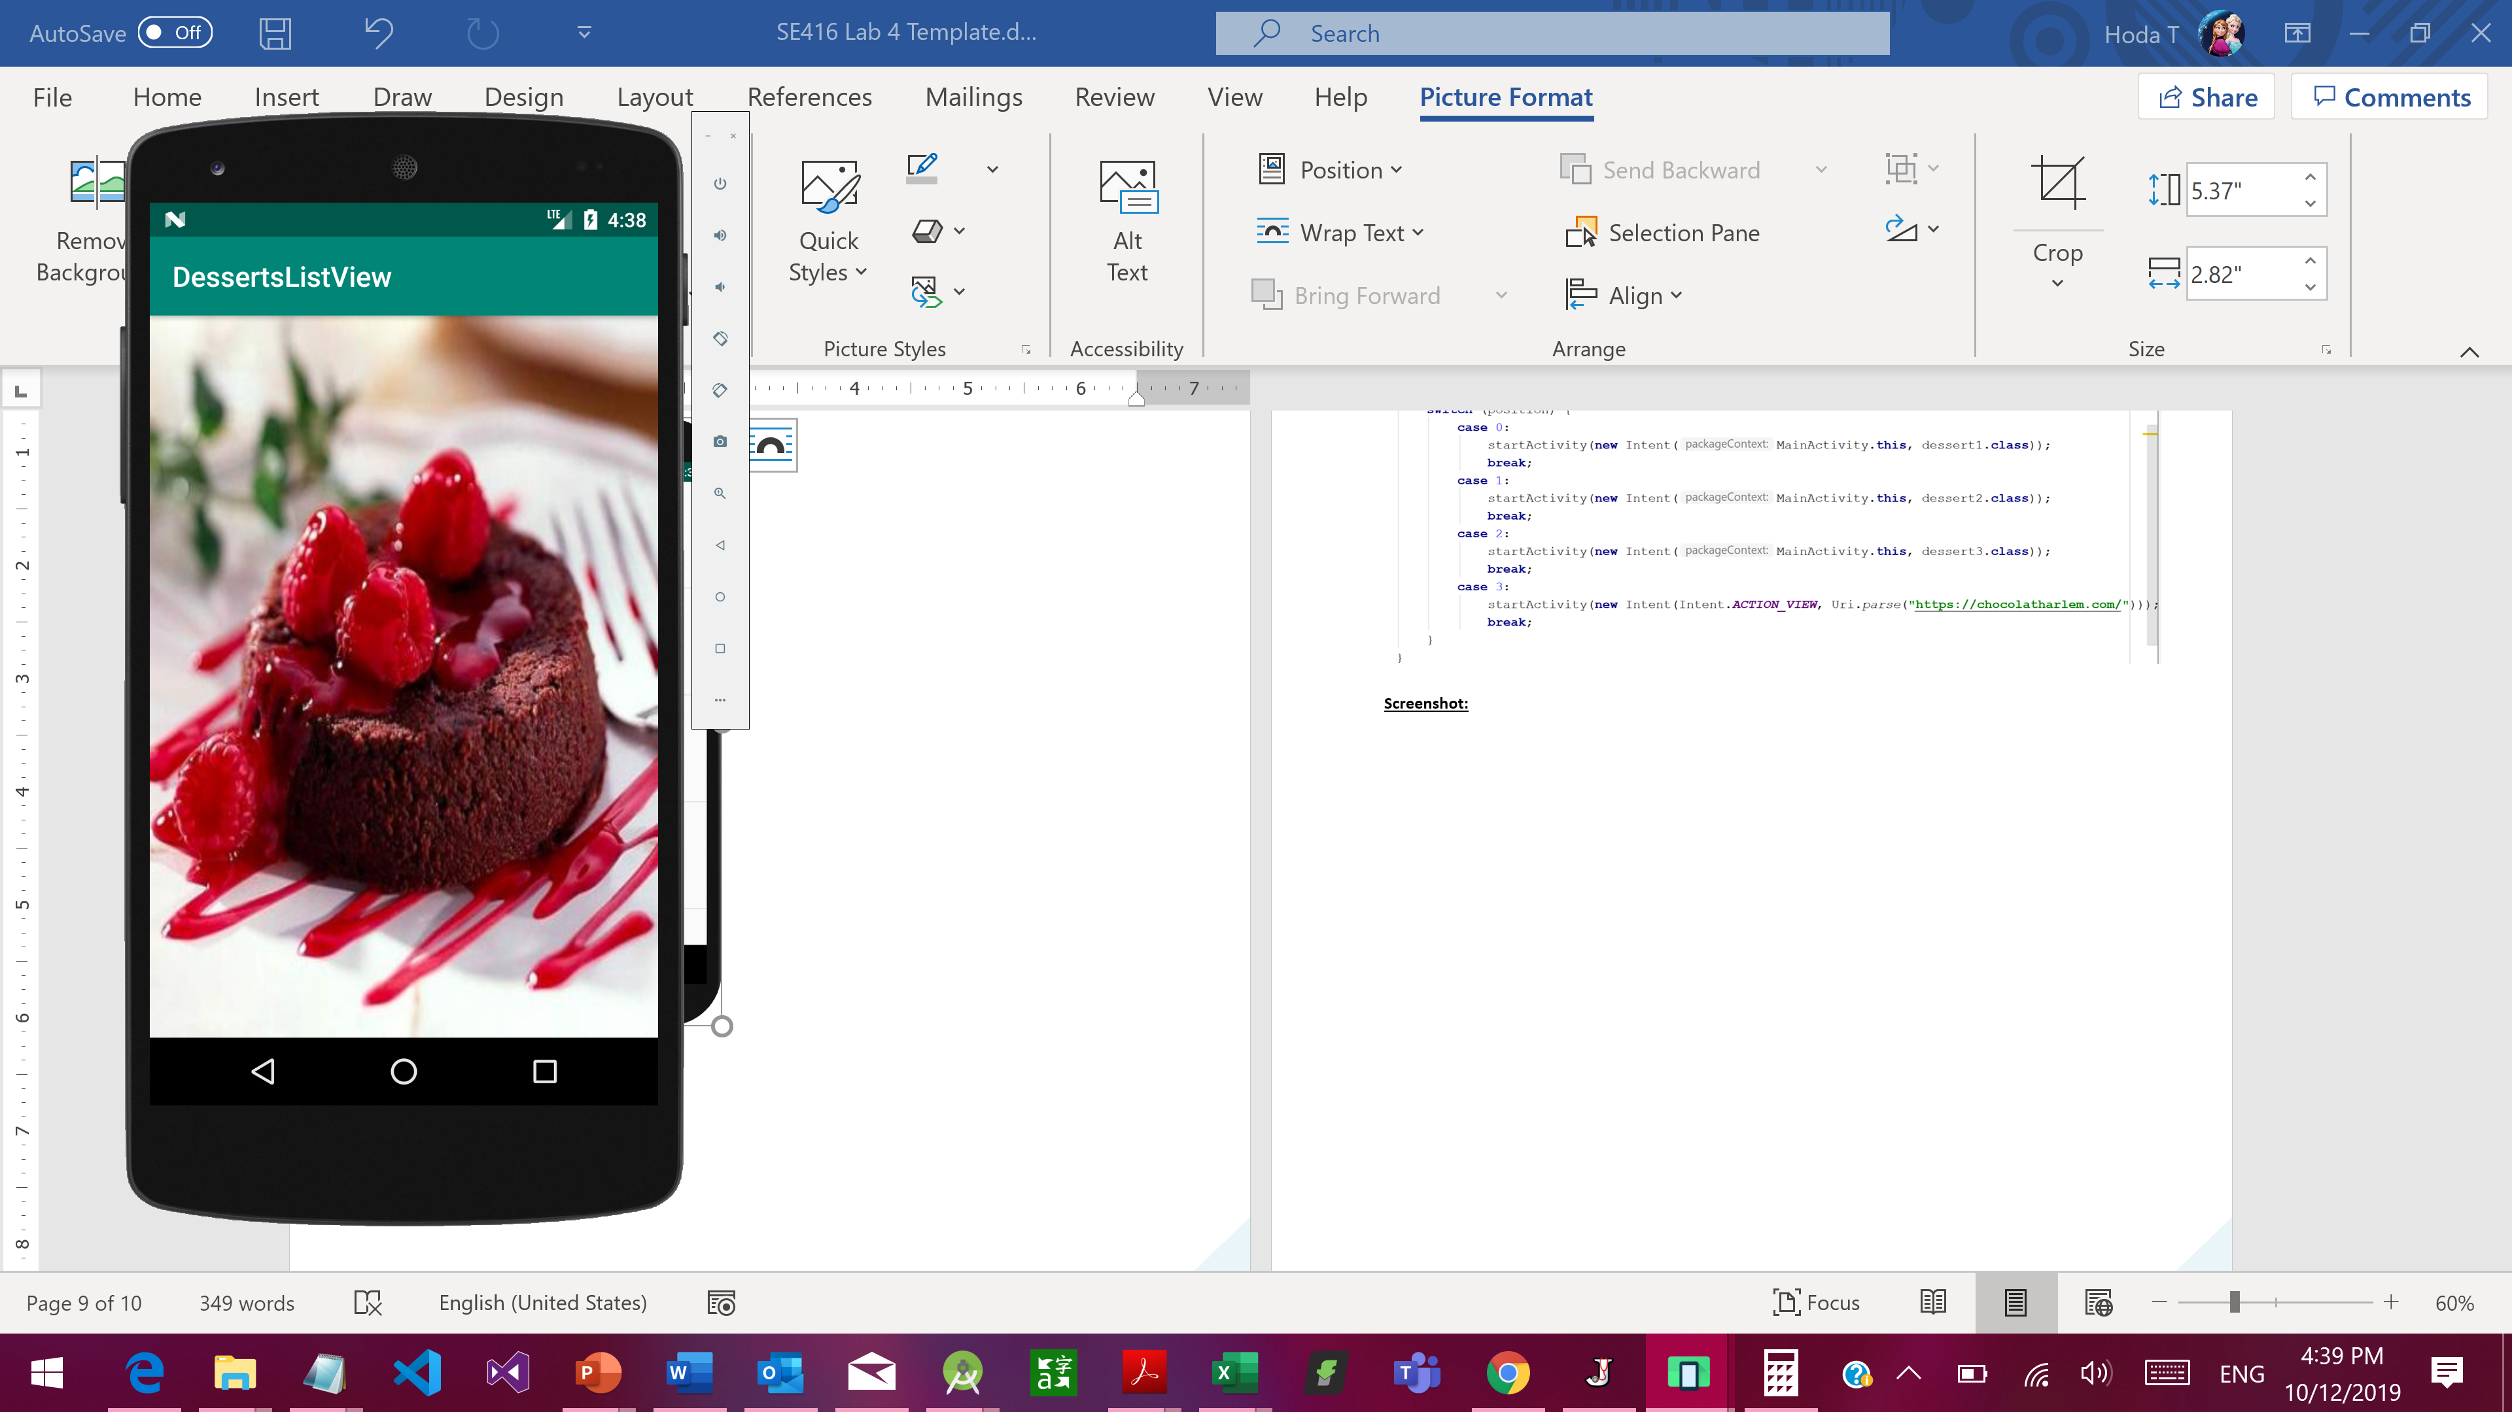

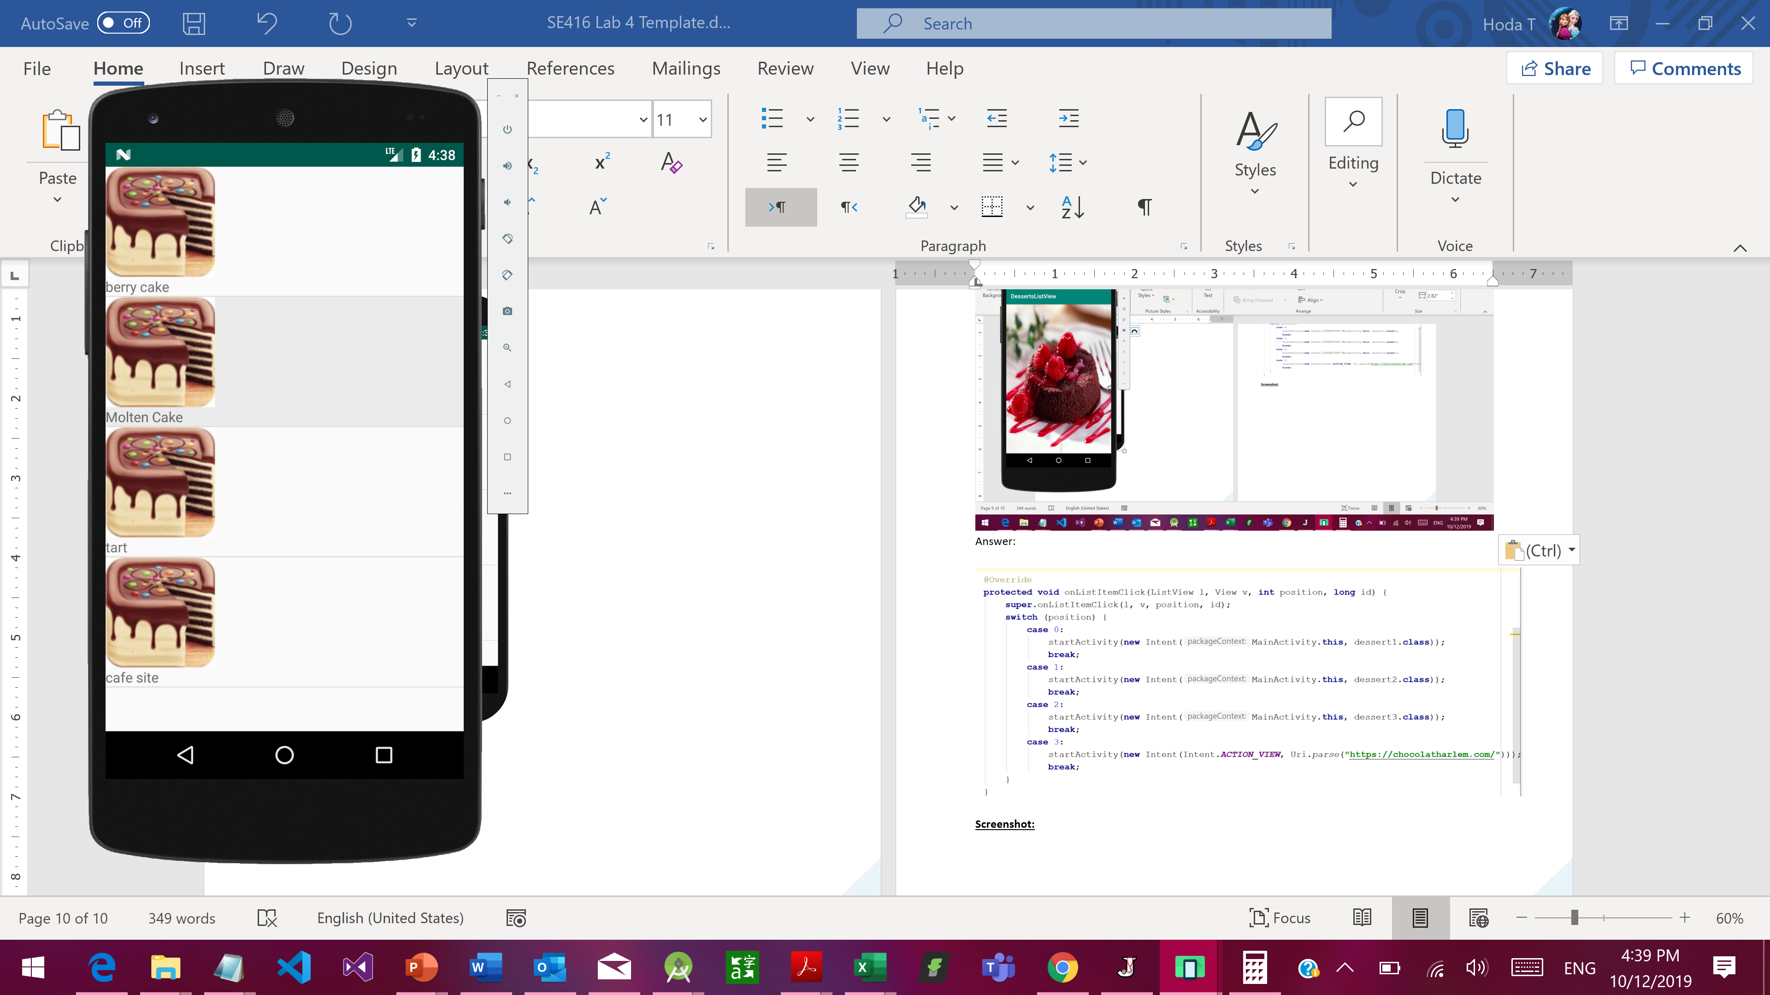 🡪 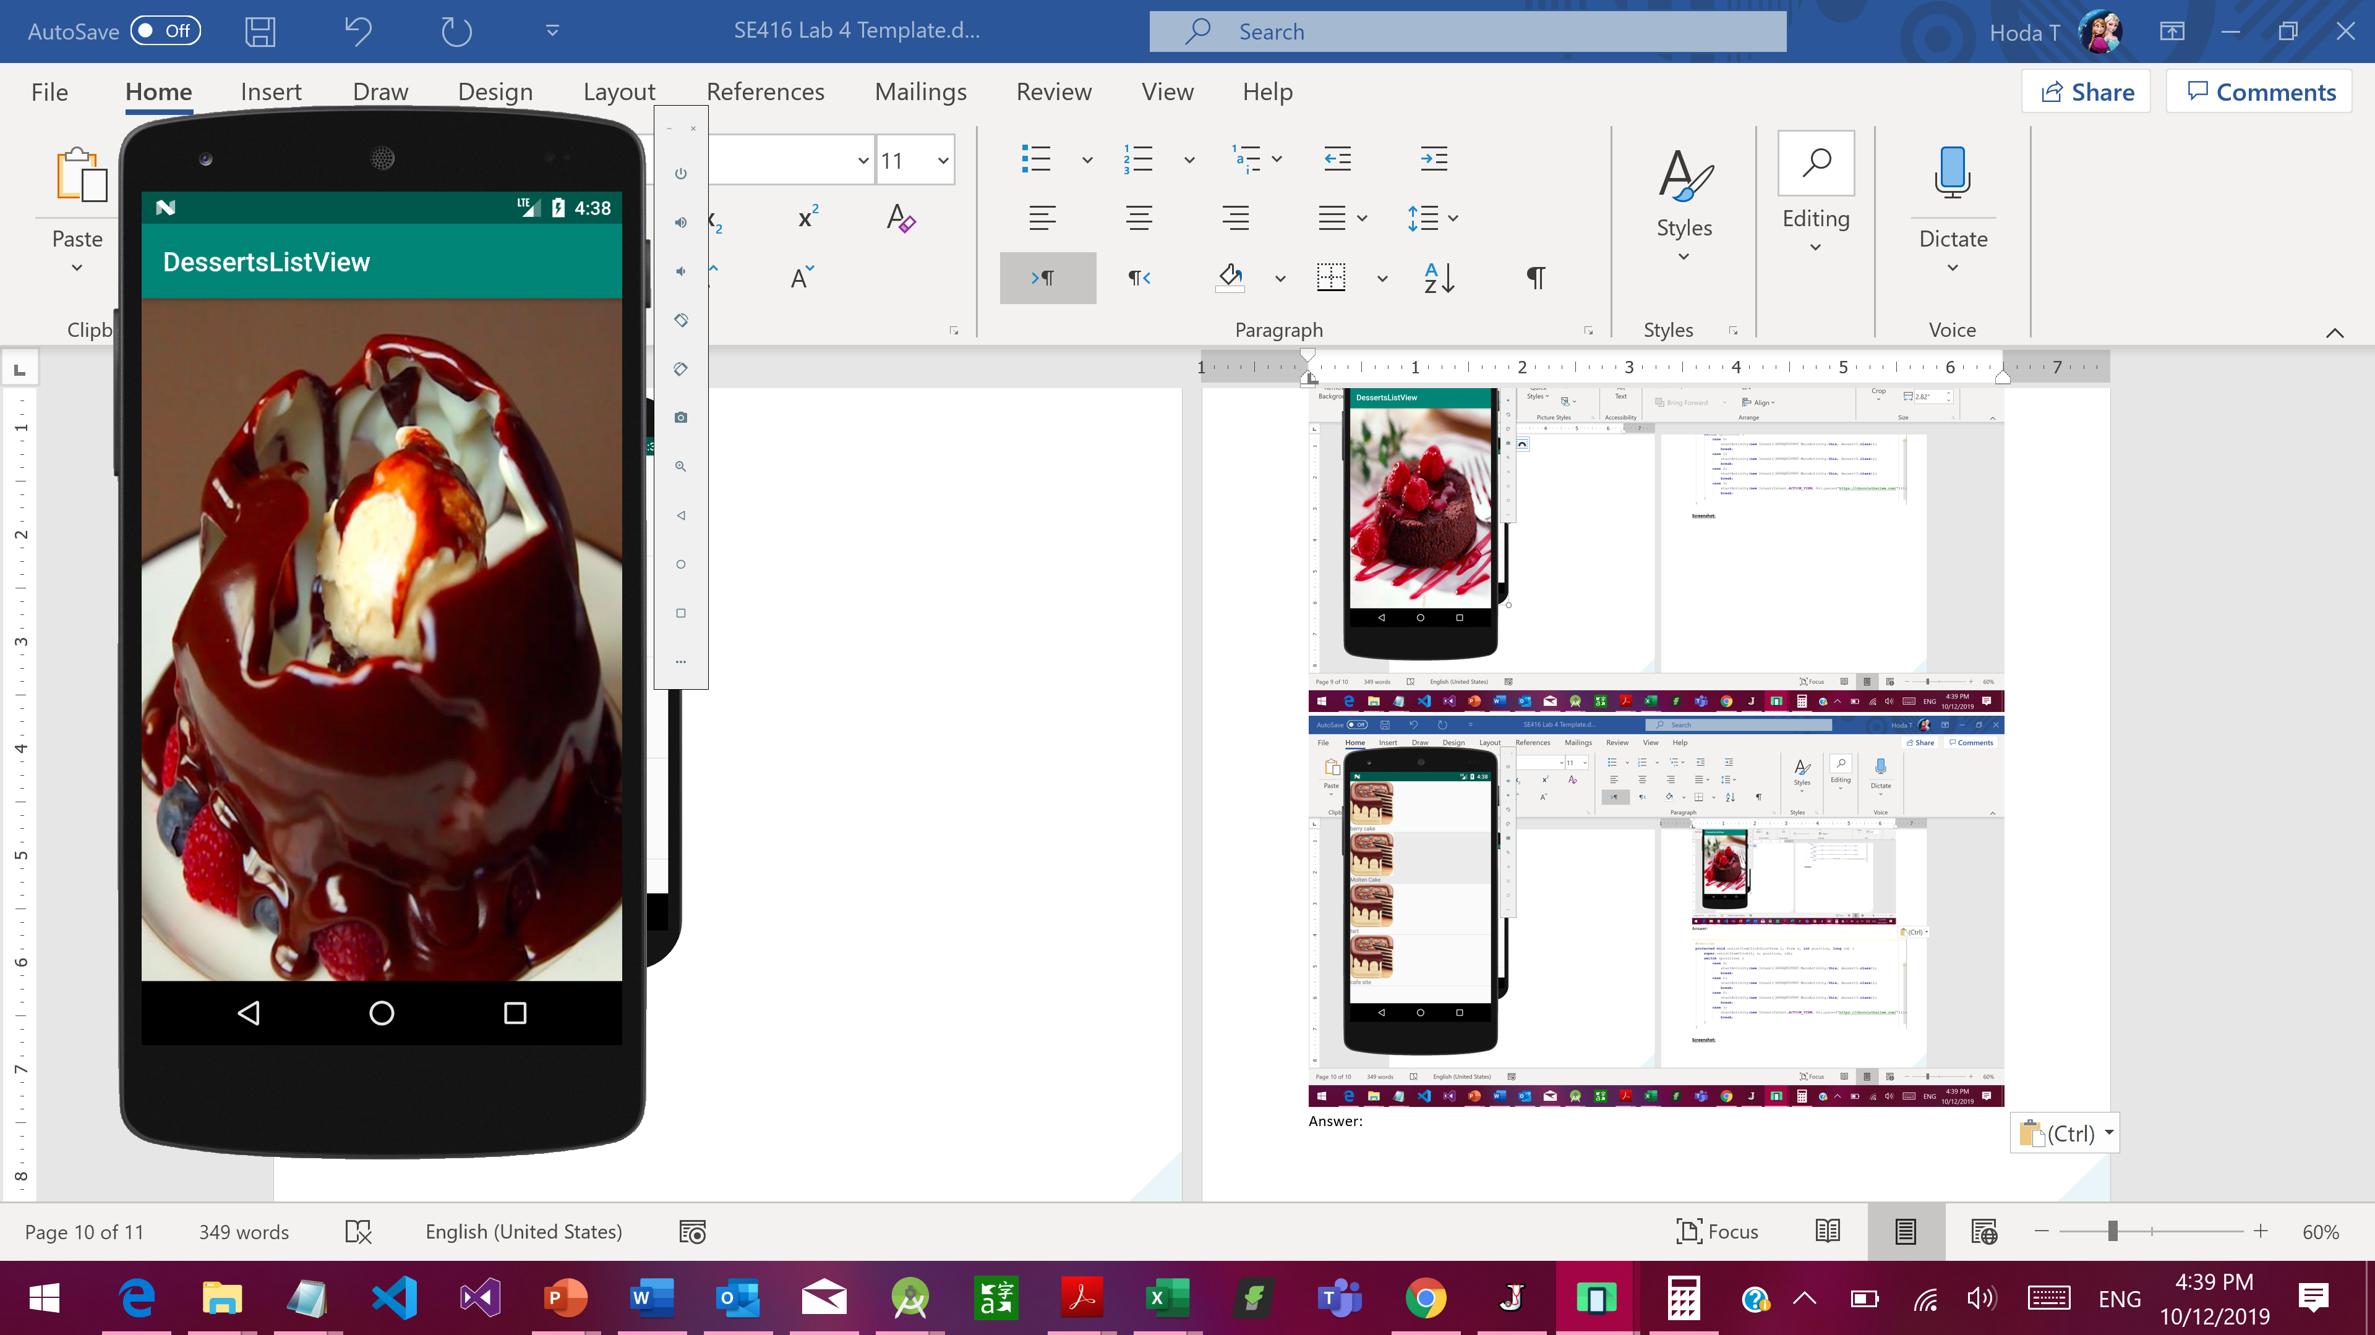

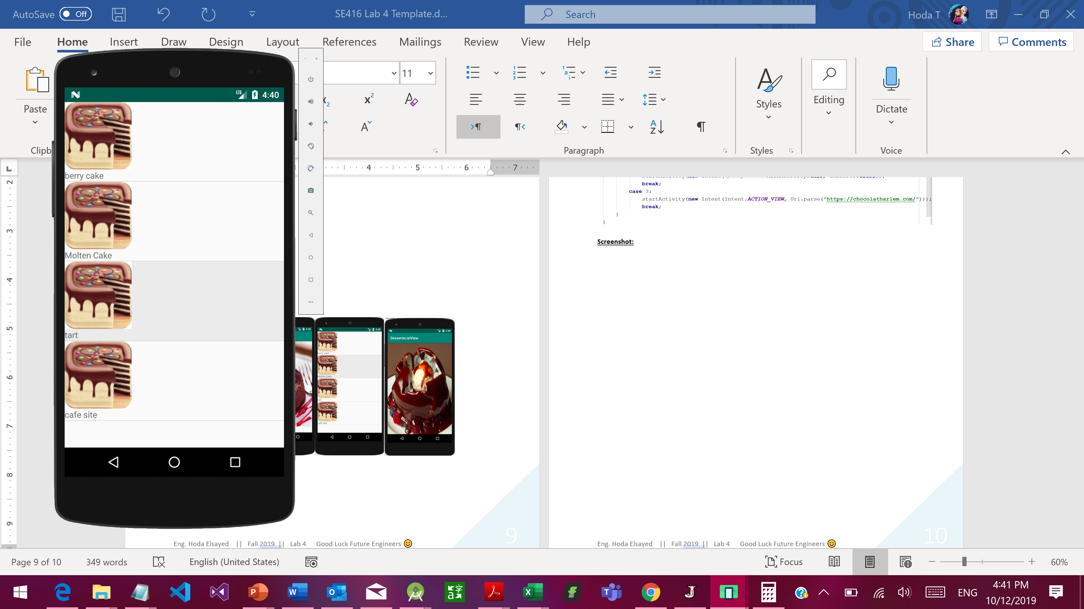 🡪 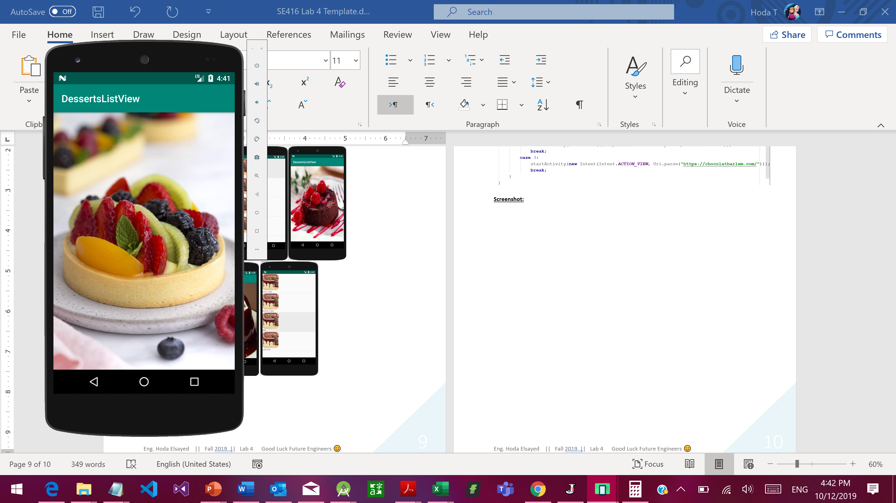

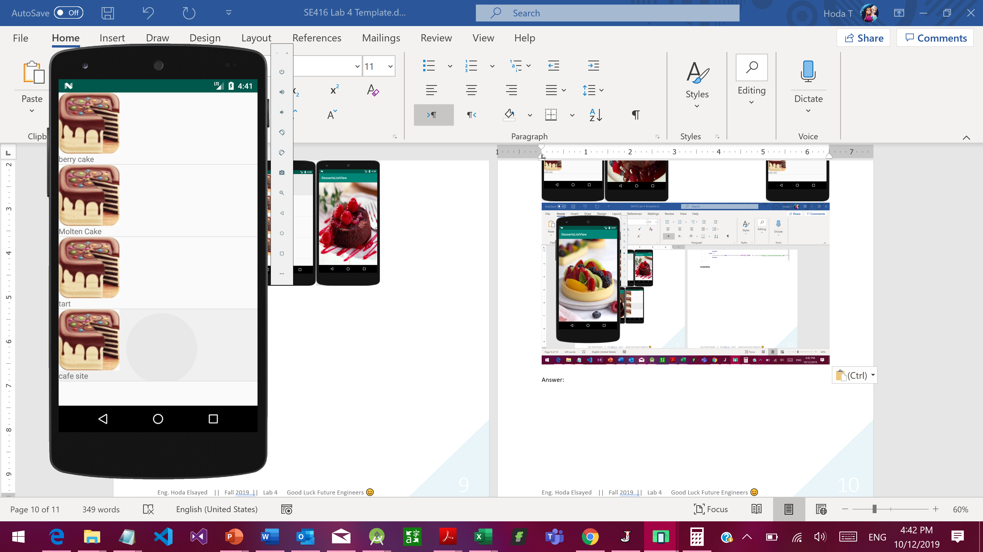 🡪 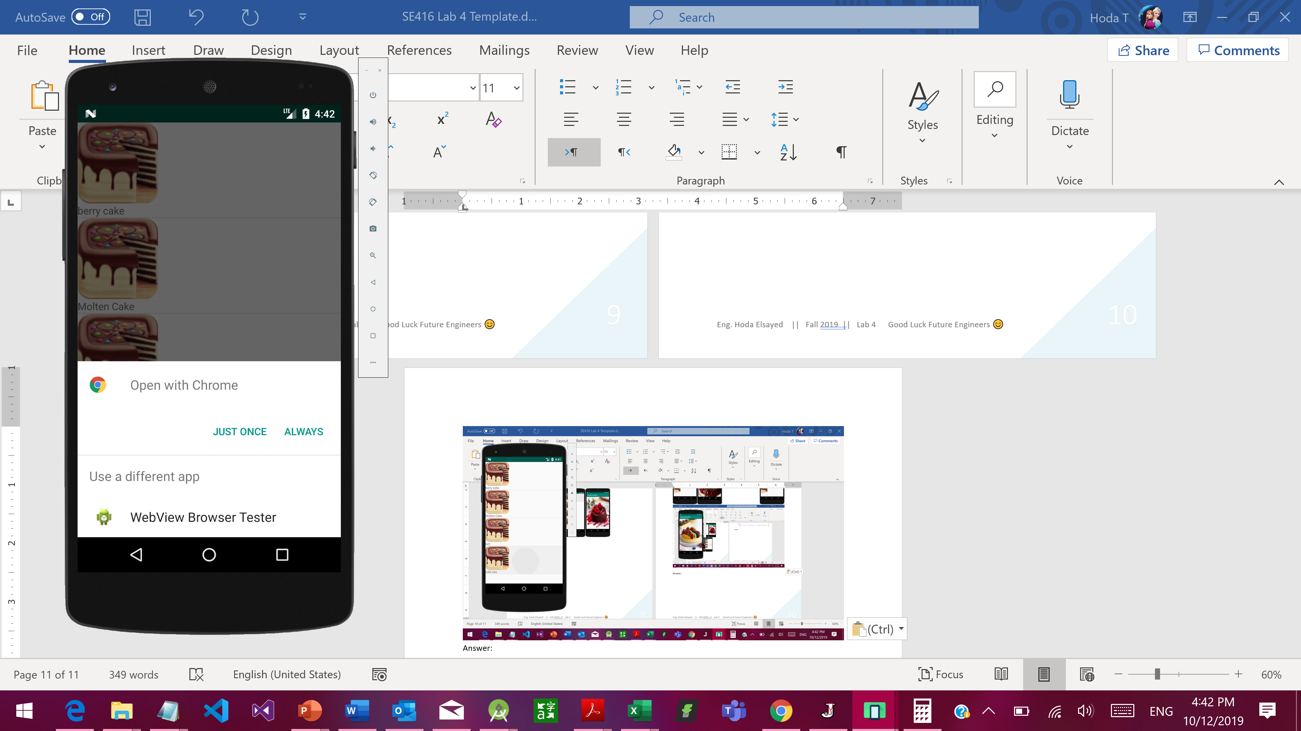 🡪 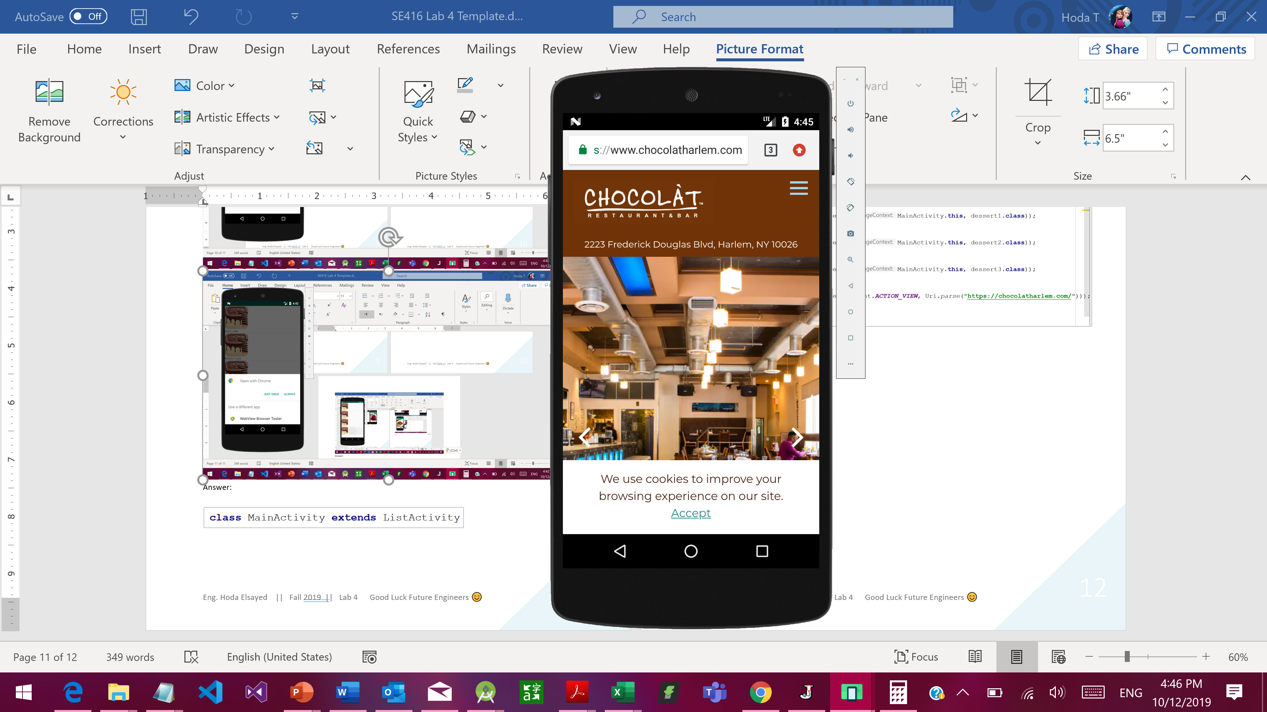

**Helping Pieces of code**

**In the activity_main.xml file**

* Your listView id should be as follows: "@android:id/list" not "@+id/list"
* The textView doesn’t have text in xml file but is rather given a ndroid:drawableTop="@drawable/icon"

**In the onCreate Method:**

* Your main class should extend ListActivity
* Create your String array that holds items names
* setListAdapter(**new** ArrayAdapter<String>(**this**,R.layout.***activity_main***,R.id.***txtViewID***, arrayName));

**In the onListItemClick ListView l, View v, int position, long id) Method:**

* Make a recursive call as: **super**.onListItemClick(l, v, position, id);
* Use switch conditions **switch** (position) { … }
* Inside switch block, you need to use:
  + startActivity(**new** Intent(current.**this**, target.**class**));
  + startActivity(**new** Intent(Intent.***ACTION_VIEW***,Uri.*parse*(**"url"**)));
  + Url is [**https://chocolatharlem.com/**](https://chocolatharlem.com/)

**Answer:**

**activity_main.xml file: (layout / component tree / xml)**

<?xml version="1.0" encoding="utf-8"?>  
<RelativeLayout xmlns:android="http://schemas.android.com/apk/res/android"  
 xmlns:app="http://schemas.android.com/apk/res-auto"  
 xmlns:tools="http://schemas.android.com/tools"  
 android:layout_width="match_parent"  
 android:layout_height="match_parent"  
 tools:context=".MainActivity">  
  
  
 <ListView  
 android:id="@android:id/list"  
 android:layout_width="wrap_content"  
 android:layout_height="match_parent"></ListView>  
  
 <TextView  
 android:id="@+id/travel"  
 android:layout_width="wrap_content"  
 android:layout_height="wrap_content"  
 android:drawableTop="@drawable/globe"  
  
 android:scaleX="0.8"  
 android:scaleY="0.8"  
 />  
  
</RelativeLayout>

**MainActivity.java:**

package com.example.lab4;  
  
import androidx.appcompat.app.AppCompatActivity;  
  
import android.app.ListActivity;  
import android.content.Intent;  
import android.net.Uri;  
import android.os.Bundle;  
import android.view.View;  
import android.widget.ArrayAdapter;  
import android.widget.ListView;  
  
public class MainActivity extends ListActivity {  
  
 @Override  
 protected void onCreate(Bundle savedInstanceState) {  
 super.onCreate(savedInstanceState);  
 setContentView(R.layout.*activity_main*);  
 String [] travel={"cairo","aswan", "Alexandria", "Restaurants page"};  
 setListAdapter(new ArrayAdapter<String>(this,R.layout.*activity_main*,R.id.*travel*,travel));  
 }  
 @Override  
 protected void onListItemClick(ListView l, View v, int position, long id) {  
 super.onListItemClick(l, v, position, id);  
  
 switch (position){  
 case 0:  
 startActivity(new Intent(MainActivity.this, cairo.class));  
 break;  
  
 case 1:  
 startActivity(new Intent(MainActivity.this, aswan.class));  
 break;  
  
 case 2:  
 startActivity(new Intent(MainActivity.this, alex.class));  
 break;  
  
 case 3:  
 startActivity(new Intent(Intent.*ACTION_VIEW*, Uri.*parse*("https://instagram.com/remood.places?igshid=pk7w6r16kulz")));  
 break;  
  
 }  
 }  
}

**Output Screenshots(show all scenarios):**

